DOCUMENTATION

ASSIGNMENT 2

STUDENT NAME: Veres Noémi
GROUP: 30423

CONTENTS

1. Objective 3
2. Problem analysis, modeling, scenarios, use cases 3
3. Design 4
4. Implementation 6
5. Results 7
6. Conclusion 7
7. Bibliography 7

Objective
The main objective of Assignment 2 is to design and implement a Queues management system with a dedicated graphical interface through which the user can insert the number of clients (N), the number of queues (Q), the simulation interval, the minimum and maximum arrival time, the minimum and maximum service time and view the results of the simulation. The clients are waiting, then they are being served and finally they leave the queues. We also compute the average waiting time, average service time, and peak hour.
The sub-objectives are the following:
- Analyze the problem and identify requirements
- Design the queues management system
- Implement the queues management system
- Test the queues management system

For this assignment, we had several methods to implement and 2 strategies. The strategies are the shortest time and shortest queues. The problem analysis will be detailed in the next chapter: 2. Problem analysis, modeling, scenarios, use cases. The design of the polynomial calculator had to be made by a specific architectural pattern. I used Conceptual Architecture, which is explained in the 3. chapter. The implementation is detailed in the 4. chapter, where all the classes are presented and their main methods. Whenever writing a program, testing is an essential part of it, however, we must remember that “The absence of evidence is not necessarily evidence of absence”. Even though all the test cases are running correctly, this does not mean that our program is free of errors as we cannot cover all the special cases. We can only minimize the chance of running into problems. Further information about testing the polynomial calculator can be found in the 5. chapter.

Problem analysis, modeling, scenarios, use cases
The functional requirements of this problem are:
- The Queues management system should allow users to insert the number of clients (N), the number of queues (Q), the simulation interval, the minimum and maximum arrival time, the minimum and maximum service time
- The Queues management system should allow users to select the strategy (shortest time or shortest queue)
- The Queues management system should allow users to start the simulation
- The Queues management system should display the real-time queues evolution
- The Queues management system should compute the average waiting time, average service time, and peak hour

Non-Functional requirements might include:
- The Queues management system should be intuitive and easy to use by the user
- The simulation should be easy-to-follow
- The Queues management system should be reliable, the result should be precise, for the user to trust our application
- The Queues management system should deal with incorrect user inputs and display messages that can help the user find the issue (for example: Wrong input data! You should insert integers. or Wrong input data! You cannot insert negative numbers.)

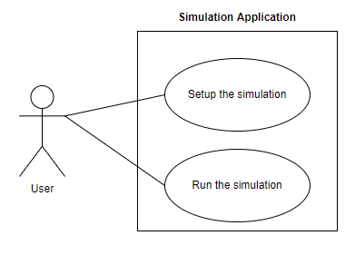
Now the use cases will be presented.

Use Case: setup the simulation
Primary Actor: user
Main Success Scenario:
1. The user inserts the values for the: number of clients, number of queues, simulation interval, minimum and maximum arrival time, and minimum and maximum service time
2. The user clicks on the “validate input data” button
3. The application validates the data and displays a message informing the user to start the simulation
Alternative Sequence: Invalid values for the setup parameters
The user inserts invalid values for the application’s setup parameters
The application displays an error message and requests the user to insert valid values
The scenario returns to step 1

Use Case: start the simulation
Primary Actor: user
Main Success Scenario:
1. The user must have validated the input data before
2. The user clicks on the “start” button
3. The application starts the simulation and displays the evolution of the queues with some other computed data
Alternative Sequence: The input data was not validated before
The user validates the data first
The scenario returns to step 1

Design
For this assignment, I have 3 packages inside ro.tuc.pt: GUI, logic, and model, as I have used a specific architectural pattern, a so-called Model View Controller pattern. In the sub-packages, I grouped the classes which are correlated. The Conceptual Architecture was also used, in which the Simulation manager, a producer, manages the assignment of Tasks to some Servers. For this, we also need a Scheduler, which sends the Tasks to the Servers according to the chosen Strategy. In our case, clients are assigned to queues, based on the shortest time or shortest queue strategy. Each Server represents a cashier, which has a queue of clients assigned.
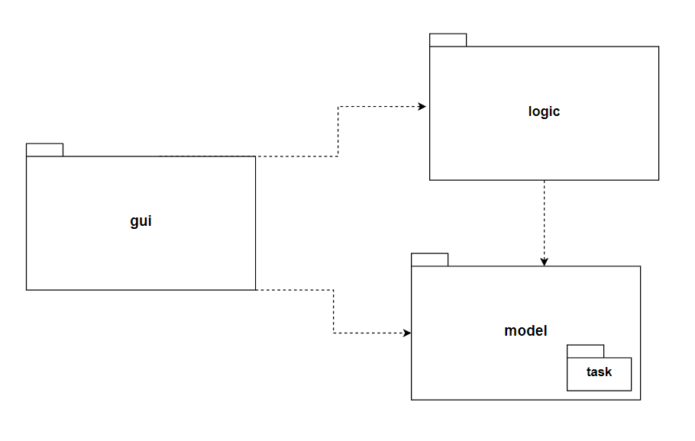
In the Model View Controller pattern, we have 3 main parts, it divides the application into 3 areas: processing, output, and input. The gui package groups the classes implementing the application’s graphical user interface, we have 2 classes here: SimulationFrame and Controller. The SimulationFrame class represents the view, here we implement the graphical user interface of the application, while the Controller class deals with the connection between the Model and the View, by implementing the ActionListener interface. It interacts with the business logic and the model. The logic package groups the classes implementing the application’s user business logic. SelectionPolicy is an enumeration that contains 2 strategies: shortest time and shortest queue. The Strategy interface contains one abstract method, which is implemented in the ConcreteStartegyTime and ConcreteStratgeyQueue classes. The Scheduler class is also in the logic package, this is the class responsible for sending the tasks to servers. The SimulationManager is another important class and this contains the main() method. This class has to generate N random tasks and update the GUI. Finally, the model class groups the classes implementing the data models of the application: Task and Server, as to one server several tasks are assigned. In the model package, I included a task package, because this one groups together two task-related classes which will be described later.
The following UML diagram shows us the dependencies between classes and the main methods of each class:

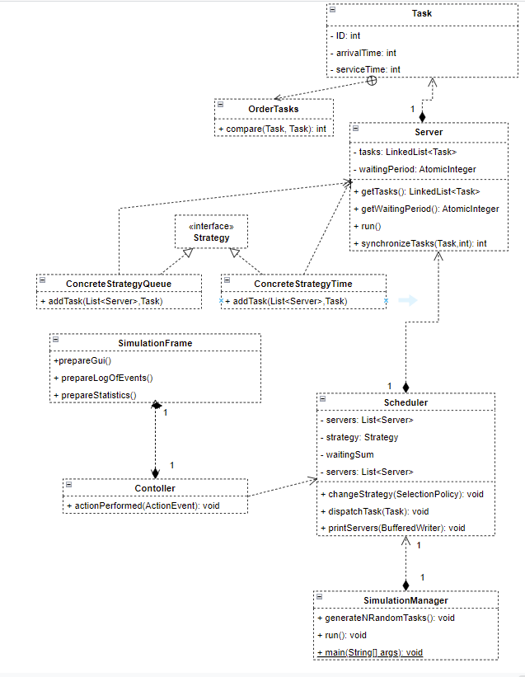

Implementation
Let us take each class separately and describe their main fields and methods.
The Server class has 2 private fields, a list of tasks, and the waitingPeriod. As for the methods, we have a constructor Server(), which allocates a new LinkedList for our tasks and sets the waitingPeriod to 0. It must be noted, that the waitingPeriod is of type AtomicInteger to avoid inconsistencies that can appear when simultaneously accessing two threads. Here we have a run() method needed for starting the threads and in order to avoid certain synchronization errors (as I did not use the thread-safe BlockingQueue), I implemented a synchronizeTasks() method.
public synchronized int synchronizeTasks(Task task, int op){
if (op == -1){
tasks.remove(task);
} else if(op == 0) {
return tasks.size();
} else if (op == 1){
tasks.add(task);
waitingPeriod.addAndGet(task.getServiceTime());
}
return -1;
}
In the Tasks class, we have 3 private fields, the ID, the arrivalTime, and the serviceTime, all of the type int. Of course, we have a constructor, getters, and setters. Inside the Task class, we have an inner class, the OrderTasks class, in which we override the compare method of the Comparator interface. This will help us to sort our tasks by their arrival time.
The SimulationFrame class is using Java Swing, to create a user-friendly graphical interface. We have many private fields here, of type JPanel, JLabel, JTextField, JCombobox – for selecting the strategy and JButton – for validating the input and then starting the simulation. The constructor receives a String, which will be the name of our application as all frames must have a name. Other methods are prepareGui(), prepareInputPanel(), prepareLogOfEvents(), preapareStatistics() and some getters, for returning different result labels, like averageWaitingTimeValueLabel or peakTimeValueLabel. I placed labels in the frame, to inform the user what they have to do.
In the Controller class, we make the connections between the View and Model. Apart from the constructor, we have an actionPerformed(ActionEvent e) method, which gets the “VALIDATE” or “START” command as a String. The input data is read and the strategy is also indicated in the graphical user interface. Using a switch case, we set the strategy operations and finally we display the simulation results.
The SimulationManager class contains the main method, which will run our application. This class has many private fields coming from the input, but other fields too for storing the intermediate and final results. It has a constructor, getters, and one of the most important methods implemented in this assignment: run(), which is an overridden method for synchronization. Another method that should be mentioned is generateNRandomTasks(), which will make a list of randomly generated clients.
That is the time when the RandomTask class becomes useful, which has 2 methods: randomTask(int id, int minArrivalTime, int maxArrivalTime, int minServiceTime, int maxServiceTime) and getIntInRange(int min, int max). The first one will return the randomly generated task and the second one will be a helper function to generate the arrival and the service time in the given range.
The Scheduler class has a constructor, which generates a list of servers with a for loop and starts each thread separately as follows:
Server newServer = new Server();
servers.add(newServer);
Thread t = new Thread(newServer);
t.start();
This class, as its name suggests, based on the QueueSelectionPolicy that was chosen, inserts a new task (which arrives at a certain time) into one of the generated queues. The dispatchTask(Task t) method is relevant from this point of view, as it calls the addTask method of strategy.
public void dispatchTask(Task t) {
waitingSum += strategy.addTask(servers, t);
}
SelectionPolicy is an enumeration with two elements: SHORTEST_QUEUE and SHORTEST_TIME, representing the two strategies for distributing tasks.
The Strategy interface contains one abstract method: addTask, which will add a task to one of the servers based on the chosen policy. The ConcreteStrategyTime and ConcreteStrategyQueue classes implement this method, the first one taking into consideration the waiting period and the second one is based on the size of the servers.

Results
For testing the results, I considered the cases from the assignment’s requirements. So I made 3 tests and their result are included in the repository. For all of these cases, the shortest time strategy was applied because I noted, that if the number of tasks, queues, simulation interval, and other input data were kept constant, then this strategy seemed to give the best results, as it guarantees that the waiting time for all tasks will be minimum. However, it should be noted that in a real-life, at a supermarket, we cannot compute the waiting time as we do not know exactly how much will be the service time for those standing in front of us. The results show us that although we tend to go to the shortest queue when we are in such a situation, this is not always the best solution, we should rather take into consideration other criteria.

Conclusion
There were many concepts and also practical things that I have learned from this assignment. I learned how to divide the whole system into smaller parts, using a specific architectural pattern, a Model View Controller in this case. The 3 main parts of this architecture are the graphical user interface (GUI), business logic, and data models.
Implementing the methods was another main part of the assignment, where Java Concurrency was important to understand. In some of the methods, synchronization errors could occur, so I had to thoughtfully implement all of them and do not let space for such errors. A key aspect for me was learning how to synchronize threads, I had to be attentive to provide a thread-safe application. I realized that I just cannot dive into implementing without thinking first or making a sketch on paper. I took some notes and wrote down some ideas and then I could implement the methods.
The SwingWorker abstract class was also new for me, but it helped me a lot in the situation where I had a running task run in a background thread and I had to provide updates to the UI either when done, or while processing.
All in all, this assignment helped me divide a complex program into small subproblems, efficiently solve them and then recombine and synchronize them to obtain a final correct result.
The application can be further developed, for example, we could run multiple simulations in parallel. It would be also interesting to combine the selection policies or just change them while the application is running. The user interface could be much more friendly by using different colors. It must be also noted that in the current situation, we cannot see how the queues evolve for a very large amount of queues and tasks, we can see only a limited part of them, so this problem should also be solved.

Bibliography

I mainly used the mvc source code for this assignment, a template provided in our Microsoft Teams class.
The presentation provided on the course website was also useful, containing some suggestions about the design and theoretical background of Java concurrency: FUNDAMENTAL PROGRAMMING TECHNIQUES (dsrl.eu)

